Bonnie Bear Day Care Registration Form

1.Basic Info
Childs Name:
Gender:
DOB:
Nationality:
Birthplace:
Lives With:
Parental Responsibility:
Collection Password:
Who is authorised to collect your child:
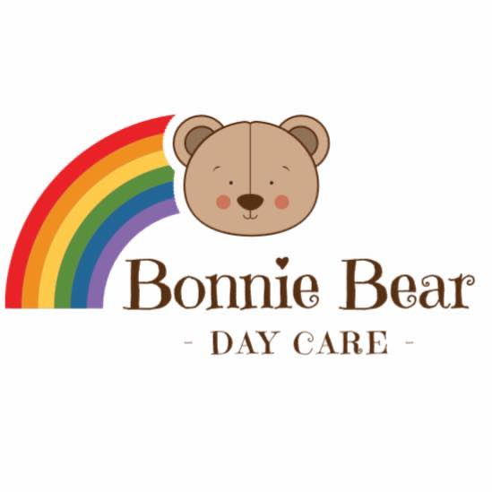
2. Health Details
Allergies:
Tolerates Penicillin: | Yes ☐ No ☐
Special Dietary Considerations:
Vaccines: | Covid ☐ Diphtheria ☐ HIB ☐ Tetanus ☐ Polio ☐ MMR ☐ Whooping Cough ☐
Additional Special Medical Notes?
Doctors Name:
Doctor Phone:
Doctor Address:

3. Sensitive Information
Religion:
Ethnicity:
4. Parent / Guardian Contacts
Family Contact 1 | Name:  Relation:  Address:  Place of work:  Occupation:  Email:  Mobile Phone:  Work Phone:  Home Phone:  Parental responsibility Yes ☐ No ☐
Family Contact 2 | Name:  Relation:  Address:  Place of work:  Occupation:  Email:  Mobile Phone:  Work Phone:  Home Phone:  Parental responsibility Yes ☐ No ☐

Family Contact 3 | Name:  Relation:  Address:  Place of work:  Occupation:  Email:  Mobile Phone:  Work Phone:  Home Phone:
Family Contact 4 | Name:  Relation:  Address:  Place of work:  Occupation:  Email:  Mobile Phone:  Work Phone:  Home Phone:
Please X your selected sessions below:
Private Non-Funded Sessions: |  |  |  |  |  | Funded Sessions
Session Title | Premium Early Drop Off | Premium Early Drop Off  Half Day Care | Standard Full Day Care | AM Half Day Care | PM Half Day Care | Full Day Care (FUNDED) | AM Half Day Care (FUNDED) | PM Half Day Care (FUNDED)
Times | 7am – 6.15pm | 7am – 12.00pm | 8am – 6.15pm | 8am - 13.00pm | 13.00 – 6.00pm | 8.00 – 3.30pm  (7.5Hours) | 8am – 1pm  (5 hours) | 1pm – 6pm  (5 hours)
Price | £49 | £25 | £46 | £23 | £23 | Meals only £3 | Meals only £2 | Meals only |£2
Mon | ☐ | ☐ | ☐ | ☐ | ☐ | ☐ | ☐ | ☐
Tues | ☐ | ☐ | ☐ | ☐ | ☐ | ☐ | ☐ | ☐
Wed | ☐ | ☐ | ☐ | ☐ | ☐ | ☐ | ☐ | ☐
Thurs | ☐ | ☐ | ☐ | ☐ | ☐ | ☐ | ☐ | ☐
Friday | ☐ | ☐ | ☐ | ☐ | ☐ | ☐ | ☐ | ☐

Please read the Nursery’s Terms and Conditions (below)
I / We have read, understood, and agree to the terms and conditions of Bonnie Bear Day Care
A refundable deposit of £100.00 is required to secure the place and the sessions selected above will not be secured until we are in receipt of this which will be refunded subject to the commencement of the place and the correct notice period of 4 weeks being given for leaving the setting.
In addition to this we will require £50.00 to cover our registration fee and this fee is non-refundable.
Signature: Name: Date:
Bank Account Details: Starling Bank Account Number: 13879217
Bank Account Name: Bonnie Bear Day Care S/C 60.83.71
Permissions (To also be acknowledged on famly App) |  |  | Signature
Medical Consent  Do you consent Bonnie Bear Day Care to seek medical or dental attention for your child if it is necessary in a case of emergency whilst in our care? | Yes ☐ | No ☐
Medication consent  Do you consent Bonnie Bear Day Care to administer prescribed medication whilst in our care? | Yes ☐ | No ☐
Permission for Nursery Outings | Yes ☐ | No ☐
Permission for Photographs on Display Boards / Nursery Prospectus / Printed Publications | Yes ☐ | No ☐
Permission to appear in media such as local Newspaper | Yes ☐ | No ☐
Photo of Child in Single & Group Photo's Including on Social Media / Website | Yes ☐ | No ☐
Sudocrem Consent  Do you consent to us applying sudocrem to you child if required? | Yes ☐ | No ☐
Sun Cream Consent  Do you agree to us applying nursery sun cream to your child whilst in our care | Yes ☐ | No ☐
Consent to Hold Personal Information  In order to register your child, it is important that we collect and safely hold information contained in this registration form securely for our records. We will hold your personal information on our system to provide the very best level of care possible and will ensure that all personal information is held securely, in line with GDPR regulations. | Yes ☐ | No ☐

